**DA5401: Data Analytics Lab**

**Assign 1**

The assignment had the task of creating a dataset from a hand-drawn image using a tool named starrydata2. Then I created a sparse Boolean matrix containing 1 for the point existing in the dataset.

This matrix mat was rotated 90 degrees clockwise using the numpy function **np.rot90(mat, k=-1)**, and then the new matrix was used to extract new coordinates of the points plotted using **np.argwhere(mat == 1)** in the display function to finally get the scatter plot of the image.

The last transformation was based on flipping the image horizontally, which was done by flipping the columns, i.e., bringing the 1st column to the last and vice versa, keeping the sequence of rows the same. It was done by this function **mat3 = mat[:, ::-1]**

Finally, we download the plots as .png images and save them in the .zip file.

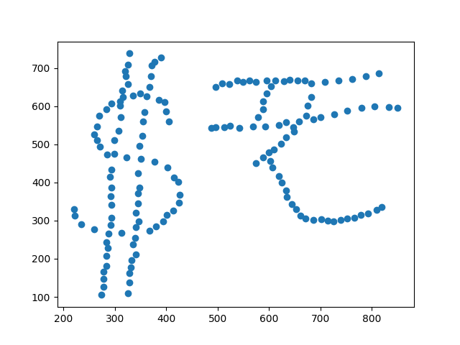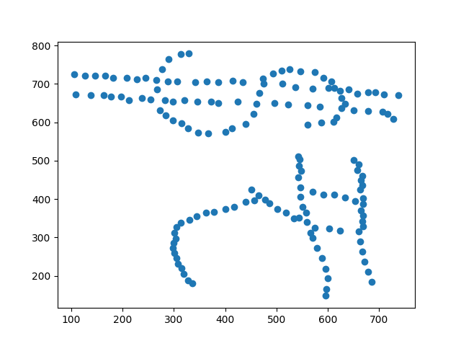

Original image

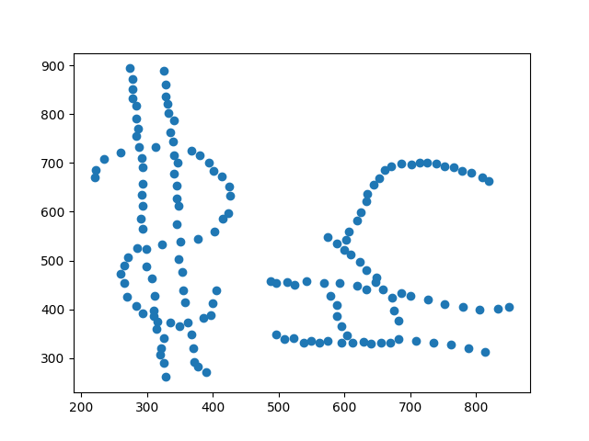

90 degrees rotated image Flipped image